Social media has become an essential part of our life, providing opportunities for people to share, search, and connect. It has also changed the way how people learn. Various social media platforms have been used to supplement (in)formal learning and training, such as Twitter and Facebook. Social media is recognized for its features to contribute to learning and increase the sense of professional community, given its affordances of enabling learners to learn with and from each other in highly situational, dynamic and interactive environments. This project aims to understand how social media can be used to facilitate learning and how people learn on social media sites through big data analytics.

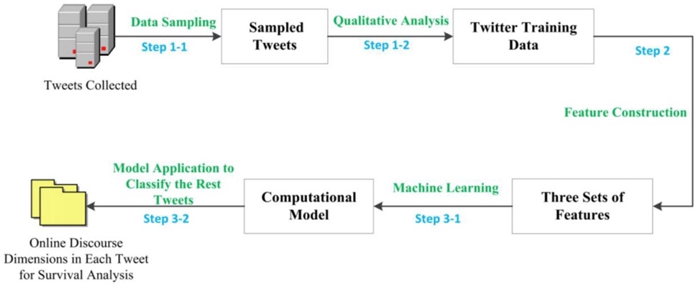

Online discourse dimension automatic detection method

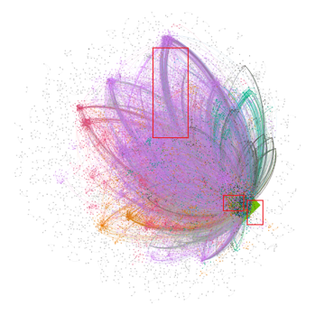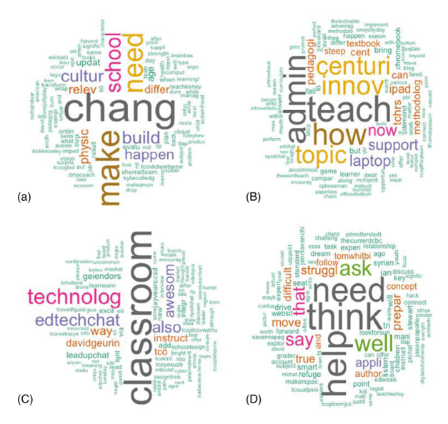

Topic examples of #edchat tweets

View of a network with (left) and without (right) hub participants

Publications

Chen, B., Chen, X., & Xing, W. (2015, March). " Twitter Archeology" of learning analytics and knowledge conferences. In *Proceedings of the Fifth International Conference on learning analytics and knowledge* (pp. 340-349).

Xing, W., & Gao, F. (2018). Exploring the relationship between online discourse and commitment in Twitter professional learning communities. *Computers & Education*, *126*, 388-398.

Du, H., Nguyen, L., Yang, Z., Abu-Gellban, H., Zhou, X., Xing, W., ... & Jin, F. (2019, July). Twitter vs news: Concern analysis of the 2018 california wildfire event. In *2019 IEEE 43rd Annual Computer Software and Applications Conference (COMPSAC)* (Vol. 2, pp. 207-212). IEEE.

Arslan, O., Xing, W., Inan, F. A., & Du, H. (2022). Understanding topic duration in Twitter learning communities using data mining. *Journal of Computer Assisted Learning*, *38*(2), 513-525.

Du, H., Xing, W., & Zhu, G. (accepted). Mining Teacher Informal Online Learning Networks: Insights from Massive Educational Chat Tweets. *Journal of Educational Computing Research.*